A Training REPORT ON

Communication between CISCO Devices

Submitted in partial fulfillment of

Bachelor of Technology in
Computer Science Engineering
Of the Rajasthan Technical University, Kota



VCET,BUNDI

Academic Session:-2017-2021

Computer Science
Submitted to:  Mr.Vijay Malav  HOD (CSE) | Submitted By:  PRAYAS YADAV  17EVNCS012  7TH SEMESTER

Department of Computer Science Engineering

VEDANT COLLEGE OF ENGINEERING & TECHNOLOGY,

BUNDI [RAJASTHAN]

Preface

Difference in the academic life and practical life is revealed when one enters in the real life and one has to forcefully follow the famous theory of Charles Darwin” Survival of the fittest”. In order to exist in the competitive world one has to be fully aware of all the aspects of industrial life. As we know engineering is not only a theoretically study but it is an implementation of all we study for creating something new and making things more easy and useful through practical study. To meet this requirement in our engineering curriculum, provision of the forty five days practical training program is provided after completion of third semester of the four year degree course.

I have undergone training at IIHT, JAIPUR. Right from the inception of this project in Cisco networking, I have tried to make company scenario by using Cisco networking for the end users. Along with the development of this scenario, there were darken moments also. I was struck up with some problems and time constraints. I had to struggle for sometime to connect with different routers, switches using different protocols. It was discouraging but it helped me indirectly, but imbibing in me an additional confidence and strength.
Finally, I would like to come clean that working on this project was indeed a great pleasure. It has helped me to reinforce many concepts and explore new knowledge. I look forward to learn from my mistakes and problems faced in this field.

Introduction

IP Addressing
CERTIFICATION OBJECTIVES
IP Addressing Introduction
IPv4 addresses are 32 bits in length. However, to make the addresses readable, they are broken into four bytes (called octets), with a period (decimal) between each byte. Let’s look at a simple example: 11111111111111111111111111111111, which is 32 1’s. This is broken up into four octets, like this: 11111111.11111111.11111111.1111111. Then each of these octets is converted into decimal, resulting in 255.255.255.255. The format of this address is commonly called dotted decimal.
Classes of Addresses
Logical, or layer-3, addresses have two components: a network and host number. The network number uniquely identifies a segment in the network and a host number uniquely identifies a device on a segment. The combination of these two numbers must be unique throughout the entire network. Network numbers is divided into five classes: Class A, B, C, D, and E. Each of these classes has a predefined network and host boundary:
■ With a Class A address, the first byte is a network number (8 bits) and the last 3 bytes are for host numbers (24 bits)
■ With a Class B address, the first two bytes are a network number (16 bits) and the last 2 bytes are for host numbers (16 bits)
■ With a Class C address, the first three bytes are a network number (24 bits) and the last 1 byte is for host numbers (8 bits)
■ Class D addresses are used for multicasting and Class E addresses are reserved
■ Class A addresses range from 1-126: 0 is reserved and represents all IP addresses; 127 is a reserved address and are used for testing, like a loop back on an interface: 00000001-01111111.
■ Class B addresses range from 128-191: 10000000-10111111.
■ Class C addresses range from 192-223: 11000000-11011111.
■ Class D addresses range from 224-239: 11100000-11101111.
■ Class E addresses range from 240-254: 255 is a reserved address and are used for broadcasting purposes.
When you are dealing with IP addresses, there are always two numbers reserved for a given network number: the first address in the network represents the network’s address, and the last address in the network represents the broadcast address for this network, commonly called a directed broadcast. There are two IP addresses reserved: 0.0.0.0 (the very first address), which represents all IP addresses, and 255.255.255.255 (the very last address), which is the local broadcast address (all devices should process this datagram). Within this range of addresses for Class A, B, and C addresses, there are some reserved addresses, commonly called Private Addresses. All the other addresses in these classes are called public addresses.
Here is a list of private addresses, which are assigned in RFC 1918:
■ Class A: 10.0.0.0-10.255.255.255 (1 Class A network)
■ Class B: 172.16.0.0-172.31.255.255 (16 Class B networks)
■ Class C: 192.168.0.0-192.168.255.255 (256 Class C networks)
IP Address Components
There are two components to addressing: network and host. The host portion is actually broken into three subcomponents: network address, host addresses, and directed broadcast address. The very first address in a network number is called the network address. This address is used to uniquely identify one segment from all of the other segments in the network. The last address in the network number is called the directed broadcast address, and is used to represent all hosts on this network segment. Middle addresses can be assigned to host devices on the segment, like PCs, servers, routers, and switches.
Host Addresses
Any number between the network address and the directed broadcast address is a host address. In An important item to point out about this process is that for any given network number, you lose two addresses. The first address in a network is reserved for the network itself and the last address is reserved for the directed broadcast address. There is a formula that defines the number of available host addresses, assuming that you know the number of bits that are reserved for host numbers: 2N - 2.
So, as an example, a Class C network has a 24-bit network number component and an 8-bit host component. Therefore, for a Class C network, the lowest address in this fourth octet is 0 and the last address in this octet is 255 (all 8 bits are set to 1). All numbers between 1-254, are host addresses for the class C network. Using the addressing formula, it can be easily shown that Class C network has 254 host addresses.
Subnetting
To overcome the efficiency issue, subnetting was introduced. Subnetting allows you to take some of the higher-order host bits in a network number and use them to create more networks. In the process of creating more networks, each of these additional networks has a lesser number of hosts. These smaller networks are commonly called subnets. Let’s look at an example. A Class C network has 8 host bits, giving you a total of 256 addresses. Of these 256 addresses, you can only use 254 for host devices, like PCs, routers, and servers. Let’s assume that you use the highest-order bit to create more networks, leaving 7 bits for host addresses. With this example, you are creating two subnets: 21 = 2. In this formula, the 1 is the number of subnet bits. In each of these subnets you have 126 host addresses: 27 - 2 = 126.
In this example, there is smaller wastage of addresses.
Subnet Masks
When dealing with TCP/IP addresses, there are actually three components to the address: A network component, a host component, and a subnet mask. The function of the subnet mask is to differentiate between the network address, the host addresses, and the directed broadcast address. Subnetting is defined in RFC 950. Like an IP address, the subnet mask is 32 bits long. In binary, a 1 in a bit position in the subnet mask represents a network component and a 0 in a bit position represents a host component. One restriction of subnet masks is that all the network bits (1s) must be contiguous and all the host bits (0s) are contiguous. A subnet mask of 111111.11111111.11111111.11111000 (255.255.255.248), however, is valid.
There are actually four methods that you can use to represent a subnet mask.
Here is a list with a demonstration using a Class C network:
■ Dotted-decimal: 192.168.1.0 255.255.255.0
■ Number of networking bits: 192.168.1.0/24
■ Hexadecimal: 192.168.1.0 0xFFFFFF00
■ Binary: 192.168.1.0 11111111111111111111111100000000
Subnet Masks Values
Given the fact that subnet mask values must have all 1’s contiguous and all 0’s contiguous. For a Class A network, the default subnet mask is 255.0.0.0: the first octet is the network number and the last three octets are the host numbers. For a Class B network, the default subnet mask is 255.255.0.0: the first two octets are the network number and the last two octets are the host numbers. For a Class C network, the default subnet mask is 255.255.255.0: the first three octets are the network number and the last octet is the host numbers.

Preparing Network Connections
CHAPTER OBJECTIVES
CERTIFICATION OBJECTIVE 4.01
Hubs
As was mentioned in Chapter 2, hubs function at the physical layer and provide a logical bus structure for Ethernet; devices connected to the hub have the illusion that they are all connected to the same physical piece of wire. Devices connected to a hub are in the same collision domain, since hubs are repeaters and they repeat any physical layer signal that they receive. Cisco has many hub products, including the following: 1500 Micro Hub; 1528 10/100 Micro Hub; 100, 200, 300, and 400 Fast Hubs.

Switches
They are normally used to solve bandwidth and collision problems. Cisco supports different switching products, including the following: 1548 Micro Switch 10/100, Catalyst 1900 and 2800, Catalyst 2950, Catalyst 3550, Catalyst 4000, Catalyst 6x00, and Catalyst 8500 switches. Most of these switches support only layer-2 functionality, like the Catalyst 1900, while others, such as the Catalyst 3550 switch, support bother layer-2 and layer-3.
Routers
As I mentioned in Chapter 2, routers are used to solve many problems, including the containment of broadcasts for home office solutions, Cisco recommends the following products: 800, 900, 1600, and 1700 series routers. For small office solutions, Cisco recommends the 1600, 1700, and 2500 series of routers. For branch office solutions, Cisco recommends the 2600, 3600, and 3700 series routers. For central site solutions, Cisco recommends the 3600, 3700, 7x00, and 12000
Connections
Cisco’s networking products support two types of external connections: ports (referred to as lines) and interfaces. Physical ports are used for management purposes and provide an out-of-band method for managing your Cisco product. Out-of-band means that your management tasks do not affect traffic that is flowing through your Cisco product. Interfaces are used to connect different networking devices together, such as a switch to router or a hub to a PC. Interfaces are connected to the backplane of the switch. You can also use interfaces for management purposes, but doing so can affect the performance of your network device. These types of connections are called in-band connections.
Console Port
Almost every Cisco product has a console port. This port is used to establish an out of-band connection in order to access the CLI to manage Cisco device. Once Out-of-band management does not affect the bandwidth flowing through your network, while in-band management does.
CERTIFICATION OBJECTIVE 4.03
Cabling
Ethernet Cabling
Ethernet has become the de facto standard for LAN implementations. At one time, there were three competing technologies: Ethernet, Token Ring, and FDDI. Because of the cost of FDDI, it was never really implemented on a wide scale but used only for backbone connections. Token Ring, however, was designed and heavily promoted by IBM. Therefore, most companies that used other LAN media types have converted to Ethernet.

Cabling Specifications
IEEE 802.3 specifies the following standards for 10 Mbps Ethernet: 10Base2, 10Base5, 10BaseT, and 10BaseFL. IEEE 802.3r specifies the following standards for 100 Mbps Ethernet, called Fast Ethernet: 100BaseFX and 100BaseTX.

Cabling Devices
With today’s implementation of Ethernet over copper, two components make up the connection: an RJ-45 connector and a Category-5 UTP cable. The cable has eight wires in it (4-pair of wires). There are two types of implementations for the pinouts of the two sides of the cable: straight-through and crossover. A straight-through cable has pin 1 on one side connected to pin 1 on the other side, pin 2 to pin 2, and so on. A straight-through cable is used for DTE-to-DCE connections. The terms DTE and DCE are typically used in WAN connections, where the DCE provides clocking. In LAN terms, a DTE is a router, PC, or file server and a DCE is a hub or a switch. Here is when you should use a straight-through cable: A crossover cable crosses over two sets of wires: pin 1 on one side is connected to pin 3 on the other and pin 2 is connected to pin 6. Crossover cables should by used when you connect a DTE to another DTE or a DCE to another DCE.

Introduction to the Cisco IOS
.
Bringing Up a Router
When you first bring up a Cisco router, it will run a power-on self-test (POST). If it passes, itwill then look for and load the Cisco IOS from flash memory—if an IOS file is present. In caseyou don’t know, flash memory is an electronically erasable programmable read-only memory—an EEPROM. The IOS then proceeds to load and looks for a valid configuration—the startupconfig— that’s stored by default in nonvolatile RAM, or NVRAM.The following messages appear when you first boot or reload a router:

System Bootstrap, Version 12.2(13)T, RELEASE SOFTWARE (fc1)
Copyright (c) 2000 by cisco Systems, Inc.
C2600 platform with 32768 Kbytes of main memory

This is the first part of the router boot process output. It’s information about the bootstrap program that first runs the POST, and then tells the router how to load, which by default is to find the IOS in flash memory. The next part, shown below, shows us that the IOS is being decompressed into RAM: program load complete, entry point: 0x80008000, size: 0x43b7fc Self decompressing the image :
After the IOS is decompressed into RAM, the IOS is then loaded and starts running the router, as shown below
Cisco Internetwork Operating System Software
IOS (tm) C2600 Software (C2600-I-M), Version 12.2(13),
RELEASE SOFTWARE (fc1)
Copyright (c) 1986-2001 by cisco Systems, Inc.
Compiled Tue 17-Dec-03 04:55 by kellythw
Image text-base: 0x80008088, data-base: 0x8080853C

Once the IOS is loaded, the information learned from the POST will be displayed next, as shown here:

cisco 2621 (MPC860) processor (revision 0x101) with
26624K/6144K bytes of memory.
Processor board ID JAD050697JB (146699779)
M860 processor: part number 0, mask 49
Bridging software.
X.25 software, Version 3.0.0.
2 FastEthernet/IEEE 802.3 interface(s)
1 Serial network interface(s)

Once the IOS is loaded, and up and running, a valid configuration will be loaded from NVRAM. If there isn’t a configuration in NVRAM, the router will go into setup mode —a step-by-step process to help you configure the router. You can also enter setup mode at any time from the command line by typing the command setup
from something called privileged mode, which I’ll get to in a minute. Setup mode only covers some very global commands, but it can be really helpful
Logging into the Router
After the interface status messages appear and you press Enter, the Router> prompt will appear. This is called user exec mode (user mode) and is mostly used to view statistics, but it’s also a stepping-stone to logging into privileged mode. You can only view and change the configuration of a Cisco router in privileged exec mode (privileged mode), which you get into with the enable command. Here’s how you would do that:
Router>
Router>enable
Router#
You now end up with a Router# prompt, which indicates you’re in privileged mode, where you can both view and change the router’s configuration. You can go back from privileged mode into user mode by using the disable command, as seen here:
Router#disable
Router>
At this point, you can type logout to exit the console:
Router>logout

Overview of Router Modes
To configure from a CLI, you can make global changes to the router by typing configure terminal (or config t for short), which puts you in global configuration mode and changes what’s known as the running-config. A global command (a command run from global config) is one that is set once and affects the entire router.
Router#config

Gathering Basic Routing Information

The show version command will provide basic configuration for the system hardware as well as the software version, the names and sources of configuration files, and the boot images. Here is an example:
Router#sh version
Cisco Internetwork Operating System Software
IOS (tm) C2600 Software (C2600-BIN-M), Version 12.2(13)T1,RELEASE SOFTWARE(fc1)
TAC Support: http://www.cisco.com/tac
Copyright (c) 1986-2003 by cisco Systems, Inc.
Compiled Sat 04-Jan-03 05:58 by ccai
Image text-base: 0x80008098, data-base: 0x80C4AD94

Setting Passwords
There are five passwords used to secure your Cisco routers: console, auxiliary, telnet (VTY), enable password, and enable secret.. This will prompt a user for a password when the enable command is used. The other three are used to configure a password when user mode is accessed either through the console port, the auxiliary port, or via Telnet
Enable Passwords
You set the enable passwords from global configuration mode like this:
Router(config)#enable ?
last-resort Define enable action if no TACACS servers
respond
password Assign the privileged level password
secret Assign the privileged level secret
use-tacacs Use TACACS to check enable passwords
Auxiliary Password
To configure the auxiliary password, go into global configuration mode and type line aux ?. You can see that you only get a choice of 0–0 (that’s because there’s only one port):
Router#config t
Enter configuration commands, one per line. End with CNTL/Z.
Router(config)#line aux ?
Console Password
To set the console password, use the line console 0 command. But look at what happened when I tried to type line console 0? From the aux line configuration—I received an error. You can still type line console 0 and it will accept it, but the help screens just don’t work from that prompt. Type exit to get back one level and you’ll find that your help screens now work. This is a “feature.” Really.
Here’s the example:
Router(config-line)#line console ?
% Unrecognized command
Router(config-line)#exit
Router(config)#line console ?
<0-0> First Line number
Router(config)#line console 0
Router(config-line)#login
Router(config-line)#password todd1

Telnet Password
To set the user-mode password for Telnet access into the router, use the line vty command. Routers that aren’t running the Enterprise edition of the Cisco IOS default to five VTY lines, through 4.
Router(config-line)#line vty 0 ?
<1-4> Last Line Number
<cr>
Router(config-line)#line vty 0 4
Router(config-line)#login
Router(config-line)#password todd2
Encrypting Your Passwords
Because only the enable secret password is encrypted by default, you’ll need to manually configure
the user-mode and enable passwords for encryption.
Router#sh running-config
[output cut]
!
enable secret 5 $1$rFbM$8.aXocHg6yHrM/zzeNkAT.
enable password todd1
!
[output cut]
line con 0
password todd1
login
line aux 0
password todd
login
line vty 0 4
password todd2
login
!
end
Router#
Router Interfaces
Different routers use different methods to choose the interfaces used on them. For instance, the following command shows a Cisco 2522 router with 10 serial interfaces, labeled 0 through 9:
Router(config)#int serial ?
<0-9> Serial interface number
The 2522 router has one Ethernet 10BaseT port, and typing interface ethernet 0 can
configure that interface, as seen here:
Router(config)#int ethernet ?
<0-0> Ethernet interface number
Router(config)#int ethernet 0
Router(config-if)#
interface type slot/port, as seen here:
Router(config)#int fastethernet ?
<0-1> FastEthernet interface number
Router(config)#int fastethernet 0
% Incomplete command.
Router(config)#int fastethernet 0?
/
Router(config)#int fastethernet 0/?
<0-1> FastEthernet interface number
You can bring up the interface with the no shutdown command (no shut for short):
Router#config t
Enter configuration commands, one per line. End with
CNTL/Z.
Router(config)#int ethernet0
Router(config-if)#no shutdown
Router(config-if)#^Z

Configuring an IP Address on an Interface
Even though you don’t have to use IP on your routers, it’s most often what people use. To configure
IP addresses on an interface use the ip address command from interface configuration mode:
Router(config)#int e0
Router(config-if)#ip address 172.16.10.2 255.255.255.0
Router(config-if)#no shut
You can verify that both addresses are configured on the interface with the show runningconfig
command (sh run for short):
Router#sh run
Building configuration...
Current configuration:
Hostnames
You can set the identity of the router with the hostname command. This is only locally significant,
which means it has no bearing on how the router performs name lookups or how the router works
on the internetwork.
Here is an example:
Router#config t
Enter configuration commands, one per line. End with
CNTL/Z.
Router(config)#hostname Todd
Todd(config)#hostname Atlanta
Atlanta(config)#
Routing Introduction
CERTIFICATION OBJECTIVES
Layer-3 devices are generically called routers. Routers basically have two functions:
1. To find a layer-3 path to a destination network
2. To move packets from one interface to another to get a packet to its destination In order to accomplish the first function, a router will need to:
■ Learn about routers it is connected to in order to learn the networks that they know about
■ Find locations of destination network numbers
■ Choose a best path to each destination
■ Maintain the most up-to-date routing information about how to reach destination networks
In order to accomplish its second function, the router will need to examine the destination IP address in an incoming IP packet, determine the network number of the destination, look in its routing table, and switch the packet to an outgoing interface.
Types of Routes
A router can learn a route via one of two methods: static and dynamic. A static route is a route that is manually configured on the router.
Dynamic routes are routes that a router learns by running a routing protocol. Routing protocols will learn about routes from other neighboring routers running the same routing protocol. Dynamic routing protocols share network numbers a router knows about and reachability information concerning these networks. There is a difference between the terms routed protocol and routing protocol. A routing protocol learns about routes for a routed protocol. A routed protocol is a layer-3 protocol, like IP or IPX. A routed protocol carries user traffic such as e-mail, file transfers, and web downloads.

Autonomous Systems
An autonomous system (AS) is a group of networks under a single administrative control, An Interior Gateway Protocol (IGP) refers to a routing protocol that handles routing within a single autonomous system. IGPs include RIP, IGRP, EIGRP, OSPF, and IS-IS. An Exterior Gateway Protocol (EGP) handles routing between different autonomous systems. Today, there is only one active EGP: the Border Gateway Protocol (BGP)
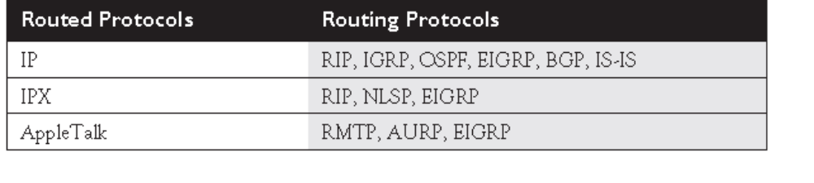

Administrative Distance
Administrative distance is a Cisco-proprietary mechanism used to rank the IP routing protocols. Administrative distance ranks the IP routing protocols, assigning a value, or weight, to each protocol. Distances can range from 0 to 255. A smaller distance is more believable by a router, with the best distance being 0 and the worst, 255.

Static Route Configuration
To configure a static route for IP, use one of these two commands:
Router(config)# ip route destination_network_# [subnet_mask]
IP_address_of_next_hop_neighbor
[administrative_distance] [permanent]
-or-
Router(config)# ip route destination_network_# [subnet_mask]
interface_to_exit
[administrative_distance] [permanent]
Optionally, you can change the administrative distance of a static route. If you omit this value, it will have one of two defaults, depending on the configuration of the previous parameter. If you specified the next hop neighbor’s IP address, then the administrative distance defaults to 1. If you specified the interface on the router it should use to reach the destination, the router treats the route as a connected route and assigns an administrative distance of 0 to it the permanent parameter will keep the static route in the routing table even when the interface the router uses for the static route fails.
Default Route Configuration
Adefault route is a special type of static route. Where a static route specifies a path a router should use to reach a specific destination, a default route specifies a path the router should use if it doesn’t know how to reach the destination.
To set up a default route, use the following syntax for a static route:
Router(config)# ip route 0.0.0.0 0.0.0.0
IP_address_of_next_hop_neighbor
[administrative_distance] [permanent]
-or-
Router(config)# ip route 0.0.0.0 0.0.0.0
interface_to_exit
[administrative_distance] [permanent]
Network 0.0.0.0 represents all networks, and a mask of all 0’s in the bit position represents all hosts in the specified network.
Verifying Static Route Configuration
To verify the configuration of static and default routes on your router, use the show
ip route command:
Router# show ip route
Codes: C - connected, S - static, I - IGRP, R - RIP,
M - mobile, B - BGP, D - EIGRP, EX - EIGRP external,
O - OSPF, IA - OSPF inter area, N1 - OSPF NSSA
external type 1, N2 - OSPF NSSA external type 2,
E1 - OSPF external type 1, E2 - OSPF external type 2,
E - EGP, i - IS-IS, L1 - IS-IS level-1, L2 - IS-IS level-2,
* - candidate default, U - per-user static route, o - ODR,
T - traffic engineered route
Gateway of last resort is not set
172.16.0.0/24 is subnetted, 3 subnets
C 172.16.1.0 is directly connected, Ethernet0
C 172.16.2.0 is directly connected, Serial0
S 172.16.3.0 is directly connected, Serial0
Router-on-a-Stick

A router-on-a-stick is a router that has a single trunk connection to a switch and that route between the VLANs on this trunk connection. You could easily do this without a trunk (access-link connections), but each VLAN would require a separate access-link (physical) connection on the router, and this would increase the price of the router solution. For instance, if you had five VLANs, and your router didn’t support trunking, you would need five physical LAN interfaces on your router in order to route between the five VLANs. However, with a trunk connection, you can route between all five VLANs on a single interface.
Subinterface Configuration
In order to set up a router-on-a-stick, you need to break up your router’s physical interface into multiple logical interfaces, called subinterfaces. Cisco supports up to 300 interfaces on a router, which includes both physical and logical interfaces. Once you create a subinterface, a router will treat this logical interface just like a physical interface
To create a subinterface, use the following command:
Router(config)# interface type port_#.subinterface_#
[point|multipoint]
Router(config-subif)#
The point parameter is used for point-to-point serial connections, and multipoint is used for multipoint connections. The multipoint parameter is used for connections that have more than one device connected to them (physically or logically).
Interface Encapsulation
Once you create a subinterface, you’ll notice that your CLI prompt has changed and that you are now in Subinterface Configuration mode. If you are routing between VLANs, you’ll need an interface that supports trunking. There are some things configured on the major interface and some things configured on the subinterface. Configurations like duplexing and speed are done on the major (or physical) interface. Most other tasks are done on the subinterface, including which VLAN the subinterface belongs to and its IP addressing information. When setting up your subinterface for a router-on-a-stick, one thing that you must configure is the type of trunking—ISL or 802.1Q—and the VLAN the subinterface is associated with, like this:
Router(config)# interface type port_#.subinterface_#
Router(config-subif)# encapsulation isl|dot1q VLAN_#
Use the encapsulation command to specify the trunk type and the VLAN associated with the subinterface.
.
Dynamic Routing Protocols
Dynamic routing protocols learn about destination networks from neighboring routers. Dynamic routing protocols fall under one of three categories: distance vector, link state, and hybrid
Routing Metrics
As mentioned in the section “Administrative Distance,” if your router has two types of routes, such as RIP and IGRP, for the same network number, the router uses the administrative distance to choose the best one. However, a situation might arise where there are two paths to the destination network, and the same routing protocol, RIP, for instance, discovers these multiple paths to the destination network. Routing protocol will use a measurement called a metric to determine which path is the best path.

Distance Vector Protocols
Distance vector routing protocols use the distance and direction (vector) to find paths to destinations. Most distance vector protocols use the Bellman-Ford algorithm for finding paths to networking destinations. Some examples of IP routing protocols that are distance vector are RIPv1 and IGRP.

Advertising Updates
One of the mechanisms of a routing protocol is to share information with neighboring routers. Some protocols use local broadcasts to disseminate information, some use multicasts, and some use unicasts. Distance vector protocols periodically use local broadcasts with a destination IP address of 255.255.255.255 to share routing information.

Processing Updates
When a distance vector protocol receives a routing update, it performs these steps:
1. Increment the metrics of the incoming routes in the advertisement (for IP RIP, add 1 to the hop count).
2. Compare the network numbers in the routing update from the neighbor to what the router has in its routing table.
3. If the neighbor’s information is better, place it in the routing table and remove the old entry.
4. If the neighbor’s information is worse, ignore it.
5. If the neighbor’s information is exactly the same as the entry already in the table, reset the timer for the entry in the routing table (in other words, the router already learned about this route from the same neighbor).
6. If the neighbor’s information is a different path to a known destination network, but with the same metric as the existing network in the routing table, the router will add it to the routing table along with the old one.
Link State Protocols
Link state protocols use an algorithm called the Shortest Path First (SPF) algorithm, invented by Dijkstra, to find the best path to a destination. , link state protocols will learn the complete topology of the network: which routers are connected to which networks. Because of the size of a network, this can create scalability problems. Therefore, link state protocols typically contain capabilities to limit the scope of their learning process, limiting a router’s knowledge of the network topology to a smaller number of routers and routes.Examples of link state protocols include IP’s OSPF and IS-IS and IPX’s NLSP.
Advertising Updates
Whereas distance vector protocols use local broadcasts to disseminate routing information, link state protocols use multicasts. Link state protocols are smarter. They multicast what is called a Link State Advertisement (LSA), which is a piece of routing information that contains who originated the advertisement and what the network number is. LSAs are typically generated only when there are changes in the network which is friendlier to your networking resources. In other words, periodic updates are rare occurrences. Link state protocols use multicasts, which are processed only by other devices running the link state protocol. Plus, link state protocols send their updates reliably. A destination router, when receiving an LSA update, will respond to the source router with an acknowledgment. As a router learns routes from the LSAs of routers in the network, it builds a complete topology of the network—what routers are connected to other routers, and what the network numbers are. The LSAs gathered by a link state router is then stored in a local database. Anytime there is a change in the database, the router runs the SPF algorithm. The SPF algorithm builds an inverted tree, with the router itself at the Top, and other routers and network segments beneath it

Hybrid Protocols
A hybrid protocol takes the advantages of both distance vector and link state protocols and merges them into a new protocol. Typically, hybrid protocols are based on a distance vector protocol but contain many of the features and advantages of link state protocols. Examples of hybrid protocols include RIPv2, EIGRP, and BGP. RIPv2

Configuring Distance Vector Protocols
CERTIFICATION OBJECTIVES
CERTIFICATION OBJECTIVE 10.01
IP Routing Protocol Basics
Before learning about how to configure RIP and IGRP, consider some basic configuration tasks that are required no matter what routing protocol you are running. You need to perform two basic steps when setting up IP routing on your router:
■ Enable the routing protocol.
■ Assign IP addresses to your router’s interfaces.
The router Command
Enabling an IP routing protocol is a two-step process. First, you must go into Router Subconfiguration mode. This mode determines the routing protocol that you’ll be running. Within this mode, you’ll configure the characteristics of the routing protocol. To enter the routing protocol’s configuration mode, use the following command:
Router(config)# router name_of_the_IP_routing_protocol
Router(config-router)#
Router(config)# router ?
bgp Border Gateway Protocol (BGP)
egp Exterior Gateway Protocol (EGP)
eigrp Enhanced Interior Gateway Routing
Protocol (EIGRP)
igrp Interior Gateway Routing Protocol (IGRP)
isis ISO IS-IS
iso-igrp IGRP for OSI networks
mobile Mobile routes
odr On Demand stub Routes
ospf Open Shortest Path First (OSPF)
rip Routing Information Protocol (RIP)
static Static routes
traffic-engineering Traffic engineered routes
Router(config)#
The network Command
Once in the routing protocol, you need to specify what interfaces are to participate in the routing process. By default, no interfaces participate. To specify which interfaces will participate, use the network Router Subconfiguration mode command:
Router(config-router)# network IP_network_#
As soon as you enter a network number, the routing process is active. For distance vector protocols like RIP and IGRP, you need to enter only the class A, B, or C network number or numbers that are associated with your interface. In other words, if you have subnetted 192.168.1.0 with a subnet mask of 255.255.255.192 (/26), and you have subnets 192.168.1.0/26, 192.168.1.64/26, 192.168.1.128/26, and 192.168.1.192/26, you don’t need to enter each specific subnet. Instead, just enter 192.168.1.0, and this will accommodate all interfaces that are associated with this class C network, in the following example, the configuration of the network commands, assuming that the routing protocol is a classful protocol, such as RIP or IGRP is given. the router is connected to a Class B network (172.16.0.0) and a Class C network(192.168.1.0), both of which are subnetted.
Router(config-router)# network 172.16.1.0
Router(config-router)# network 172.16.2.0
Router(config-router)# network 192.168.1.64
Router(config-router)# network 192.168.1.128

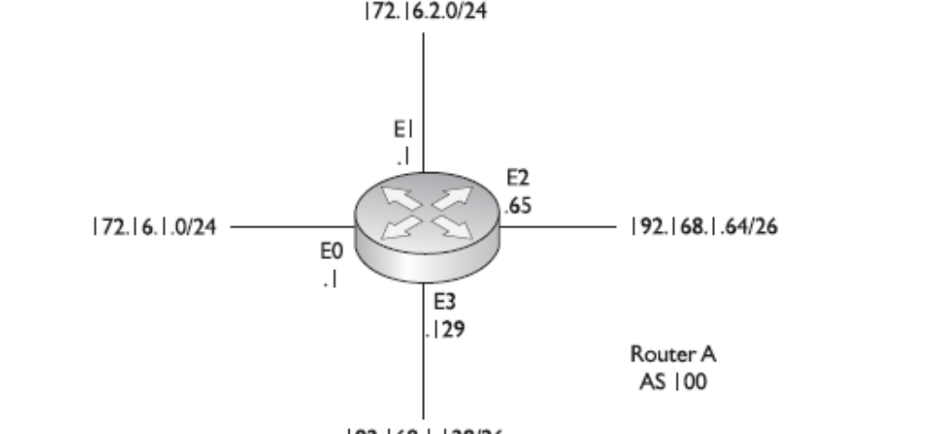
IP RIP
IP RIP (Routing Information Protocol) comes in two different versions: 1 and 2. Version 1 is a distance vector protocol. Version 2 is a hybrid.
RIPv1
RIPv1 uses local broadcasts to share routing information. These updates are periodic in nature, occurring, by default, every 30 seconds, with a hold-down period of 180 seconds. Both versions of RIP use hop count as a metric, which is not always the best metric to use. For instance, if you had two paths to reach a network, where one was a two-hop Ethernet connection, and the other was a one-hop 64 KbpsWANconnection, RIP would use the slower 64 Kbps connection because it has a lesser hop count value. Forever, both versions of RIP solve counting to infinity by placing a hop count limit of 15 hops on packets. Any packet that reaches the sixteenth hop will be dropped. Another interesting feature is that RIP supports up to six equal-cost paths to a single destination, where all six paths can be placed in the routing table and the router can load-balance across them. The default is actually four paths, but this can be increased up to a maximum of six.
Let’s look at Figure 10-2 to illustrate equalcost- path load balancing. In this example, RouterA has two equal-cost paths to 10.0.0.0 (with a hop count of 1) via RouterB and RouterC. There are actually two advantages of putting both of these paths in RouterA’s routing table:
■ First, the router can perform load balancing to 10.0.0.0, taking advantage of the bandwidth on both of these links.
■ Second, convergence is sped up if one of the paths fails. For example, if the connection between RouterA and RouterB fails, RouterA can still access network 10.0.0.0 via RouterB and has this information in its routing table; therefore, convergence is instantaneous.
Configuring IP RIP
As you will see in this section, configuring RIP is a very easy and straightforward process. The basic configuration of RIP involves the following two commands:
Router(config)# router rip
Router(config-router)# network IP_network_#
As explained in the preceding section, RIPv1 is
classful and RIPv2 is classless. However, whenever
you configure either version of RIP, the network
command assumes classful: You need to enter only
the Class A, B, or C network number, not the
subnets, as was discussed earlier in this chapter.
If you refer back to Figure 10-1, the router’s RIPv1
configuration would look like this:
Router(config)# router rip
Router(config-router)# network 172.16.0.0
Router(config-router)# network 192.168.1.0

Troubleshooting IP RIP
Once you have configured IP RIP, you have a variety of commands available to view and troubleshoot your configuration and operation of RIP:
■ show ip protocols
■ show ip route
■ debug ip rip

One other important command to point out is the clear ip route * Privilege EXEC mode command. This command clears and rebuilds the IP routing table . Please note that the clear command only clears dynamic routes: static and connected routes cannot be cleared from the routing table with this command.
The show ip protocols Command
The show ip protocols command displays all of the IP routing protocols that you have configured and are running on your router. Here’s an example of this command:
Router# show ip protocols
Routing Protocol is "rip"
Sending updates every 30 seconds, next due in 5 seconds
Invalid after 180 seconds, hold down 180, flushed after 240
Outgoing update filter list for all interfaces is not set
Incoming update filter list for all interfaces is not set
Redistributing: rip
Default version control: send version 1, receive any version
Interface Send Recv Key-chain
Ethernet0 1 1 2
Ethernet1 1 1 2

In this example, RIP is running on the router. The routing update interval is 30 seconds, with the next update being sent in 5 seconds. You can see that two interfaces are participating: ethernet0 and ethernet1. On these interfaces, RIPv1 is being used to generate updates and both versions are accepted if they are received on these two interfaces. You can see the two networks specified with the network commands: 192.168.1.0 and 192.168.2.0. In this example, this router received an update 22 seconds ago from a neighboring router: 192.168.2.2. And last, the default administrative distance of RIP is 120.
The show ip route Command
To view the routing table, use the show ip route command:
Router# show ip route
Codes: C - connected, S - static, I - IGRP, R - RIP,
M - mobile, B - BGP, D - EIGRP, EX - EIGRP external,
O - OSPF, IA - OSPF inter area, N1 - OSPF NSSA
external type 1, N2 - OSPF NSSA external type 2,
E1 - OSPF external type 1, E2 - OSPF external type 2,
E - EGP, i - IS-IS, L1 - IS-IS level-1,
L2 - IS-IS level-2, * - candidate default,
U - per-user static route, o - ODR,
T - traffic engineered route

IP IGRP

The Interior Gateway Routing Protocol (IGRP) is a Cisco-proprietary routing protocol for IP. Like IP RIPv1, it is a distance vector protocol. However, it scales better than RIP because of these advantages:
■ It uses a sophisticated metric based on bandwidth and delay.
■ It uses triggered updates to speed-up convergence.
■ It supports unequal-cost load balancing to a single destination.
IGRP uses a composite metric, which includes bandwidth, delay, reliability, load, and MTU, when choosing paths to a destination. By default, the algorithm uses only bandwidth and delay, but the other metric components can be enabled. Reliability and load are measured 1–255. A reliability of 1 is least reliable, while 255 is most reliable. A load of 1 is least utilized, while 255 is 100 percent utilized
For instance, if you have a 64 Kbps WAN link to a destination and a two-hop Ethernet connection to the same destination, RIP would choose the slowWAN link, but IGRP would choose the two-hop Ethernet connection. IGRP routing updates are broadcasted every 90 seconds with a hold-down period of 280 seconds.
Configuring IP IGRP
Setting up IGRP is almost as simple as configuring RIP:
Router(config)# router igrp autonomous_system_#
Router(config-router)# network IP_network_#
Unlike RIP, IGRP understands the concept of an autonomous system and requires you to configure the autonomous system number in the routing process. For routers to share routing information, they must be in the same AS. IGRP routing updates contain the AS number of the advertising router. When a receiving router examines the advertisement, it compares the AS in the update and its own AS number. If they don’t match, the router discards the update. The network command configuration is as the same as for RIP. To specify which interfaces are participating in the IGRP routing process, you use the network command. The syntax and configuration of this command are exactly like those for RIP. Since IGRP is a distance vector protocol, you need to specify only the class network number
Load Balancing
Router will use only the best metric paths the multiplier can range from 1 to 128. The default is 1, which means the IGRP IGRP supports both equal- and unequal-cost paths for load balancing to a single destination. Equal-cost paths are enabled by default, where IGRP supports up to six equal-cost paths (four by default) to a single destination in the IP routing table. IGRP, however, also supports unequal-cost paths, but this feature is disabled by default. The variance feature allows you to include equal- and unequal-cost IGRP routes in the routing table. To enable unequal-cost paths for IGRP, use the variance Router Subconfiguration mode command:
Router(config-router)# variance multiplier
The multiplier value is a positive integer. By default, it is equal to one. To use an unequal-cost path (less preferred), you multiply the best metric path by the multiplier value; if the less preferred path’s metric is less than this value, the router will include it in the routing table along with the best metric path.
You can override this behavior with the traffic-share Router Subconfiguration
mode command:
Router(config-router)# traffic-share balanced
-or-
Router(config-router)# traffic-share min across-interfaces
The first command provides the default behavior for load balancing, the min parameter has the router put the unequal-cost paths in the router’s routing table; however, the router won’t use these routes unless the best metric route fails.

Configuration Example
Let’s return to the example shown in earlier Figure 10-1, to help illustrate how to configure IGRP on a router. Here’s the complete configuration of the router:
Router(config)# router igrp 100
Router(config-router)# network 172.16.0.0
Router(config-router)# network 192.168.1.0
Router(config-router)# exit
Router(config)# interface ethernet 0
Router(config-if)# ip address 172.16.1.1 255.255.255.0
Router(config-if)# no shutdown
Router(config-if)# exit
Router(config)# interface ethernet 1
Router(config-if)# ip address 172.16.2.1 255.255.255.0
Router(config-if)# no shutdown
Router(config-if)# exit
Router(config)# interface ethernet 2
Router(config-if)# ip address 192.168.1.65 255.255.255.192
Router(config-if)# no shutdown
Router(config-if)# exit
Router(config)# interface ethernet 3
Router(config-if)# ip address 192.168.1.129 255.255.255.192
Router(config-if)# no shutdown
Router(config-if)# exit

Troubleshooting IP IGRP
You have the same tools available to you in IGRP as you did in RIP to help troubleshoot
the routing protocol:
■ show ip protocols
■ show ip route
■ debug ip igrp events
■ debug ip igrp transactions
OSPF
The Open Shortest Path First (OSPF) protocol is a link state protocol that handles routing for IP traffic
Characteristics of OSPF
OSPF was created in order to overcome many of the deficiencies and scalability problems that RIP had in large enterprise networks.
■ It will run on most routers, since it is based on an open standard.
■ It uses the SPF algorithm, developed by Dijkstra, to provide a loop-free topology.
■ It provides fast convergence with triggered, incremental updates via Link State Advertisements (LSAs).
■ It is a classless protocol and allows for a hierarchical design with VLSM and route summarization.
Given its advantages, OSPF does have its share of disadvantages:
■ It requires more memory to hold the adjacency (list of OSPF neighbors), topology (a link state database containing all of the routers and their routes), and routing tables.
■ It requires extra CPU processing to run the SPF algorithm, which is especially true when you first turn on your routers and they are initially building the adjacency and topology tables.
■ For large networks, it requires careful design to break up the network into an appropriate hierarchical design by separating routers into different areas.
■ It is complex to configure and more difficult to troubleshoot.

Hierarchical Design: Areas
To provide scalability to very large networks, OSPF supports two important concepts: autonomous systems and areas. Within an AS, areas are used to provide hierarchical routing. Basically, areas are used to control when and how much routing information is shared across your network. In flat network designs, such as IP RIP, if a change occurs on one router, perhaps a flapping route problem, it affects every router in the entire network. With a correctly designed hierarchical network, these changes can be contained within a single area. OSPF implements a two-layer hierarchy: the backbone (area 0) and areas off of the backbone (areas 1–65,535), as is shown in Figure 11-1. By summarizing your routing information, perhaps one summarized route for each area, you are reducing the amount of information that routers need to know about. For instance, each area in Figure 11-1 is assigned a separate Class B network number. For instance, Area 2 doesn’t need to see all of the subnets of Area 3’s 172.18.0.0 network number, since there are only two paths out of Area 2 to the backbone. Area 2, however, needs to see all of its internal subnets to create optimized routing tables to reach internal networks its own areas and summarized routes to reach other areas

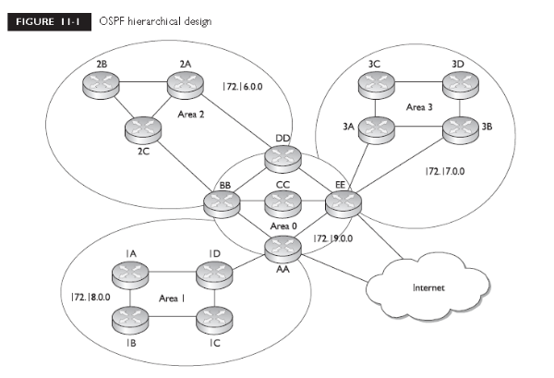
Metric Structure
Unlike RIP, which uses hop count as a metric, OSPF uses cost. Cost is actually the inverse of the bandwidth of a link: the faster the speed of the connection, the lower the cost. The most preferred path is the one with the lowest cost. By using cost as a metric, OSPF will choose more intelligent paths than RIP.
Router Identities
Each router in an OSPF network needs a unique ID. The ID is used to provide a unique identity to the OSPF router. This is included in any OSPF messages the router generates. The router ID is chosen according to one of the two following criteria:
■ The highest IP address on its loopback interfaces (this is a logical interface on
a router)
■ The highest IP address on its active interfaces
If you have an IP address on an active loopback interface, the router will use the highest IP address from the bunch for its router ID.. If there is no active interface, the OSPF process will not start and therefore you will not have any OSPF routes in your routing table.
Finding Neighbors
OSPF learns about its neighbors and builds its adjacency and topology tables by sharing LSAs. There are different types of LSAs. When learning about the neighbors that a router is connected to, as well as keeping tabs on known neighbors, OSPF routers will generate hello LSAs every 10 seconds. When a neighbor is discovered and an adjacency is formed with the neighbor, a router expects to see hello messages from the neighbor. If a neighbor is not seen within the dead interval time, which defaults to 40 seconds, the neighbor is declared dead. When this occurs, the router will advertise this information, via an LSA message, to other neighboring OSPF routers. Before a router will accept any routing information from another OSPF router, they have to build an adjacency with each other on their connected interfaces. When this adjacency is built, the two routers (on the connected interfaces) are called neighbors, which indicates a special relationship between the two let’s assume that you turned on all your routers simultaneously on a segment. In this case, the OSPF routers will go through three states called the exchange process:
Designated and Backup Designated Routers
An OSPF router will not form adjacencies to just any router. Instead, a client/server design is implemented in OSPF. For each network multi-access segment, there is a DR and a BDR as well as other routers. As an example, if you have ten VLANs in your switched area, you’ll have ten DRs and ten BDRs. The one exception of a segment not having these two routers is on a WAN point-to-point link.
OSPF routers use Link State Advertisements (LSAs) to communicate with each other. One type of LSA is a hello, which is used to form neighbor relationships and as a keep-alive function. Hellos are generated every ten seconds. When sharing link information (directly connected routes), links are sent to the DR (224.0.0.6) and the DR disseminates this to everyone (224.0.0.5) else on the segment. The router with the highest priority (or highest router ID) becomes the DR. This process is true for multi-access segments, but not point-to-point links, where DRs are not necessary. Figure 11-2 shows an example of the election process, where router E is elected as the DR and router B, the BDR.

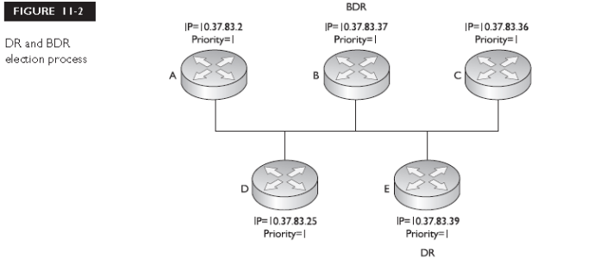

Sharing Routing Information
After electing the DR/BDR pair, the routers continue to generate hellos to maintain communication. This is considered an exstart state, in which the OSPF routers are ready to share link state information. The process the routers go through is called an exchange protocol:
1. Exstart state The DR and BDR form adjacencies with the other OSPF routers on the segment, and then within each adjacency, the router with the highest router ID becomes the master and starts the exchange process first The remaining router in the adjacency will be the slave.
2. Exchange state the master starts sharing link state information first, with the slave. These are called DBDs (database description packets), also referred to as DDPs. The DBDs contain the link-state type, the ID of the advertising router, the cost of the advertised link, and the sequence number of the link.
3. Loading state If the master has more up-to-date information than the slave, he slave will respond to the master's original DBD with an LSR (Link State request). The master will then send a LSU (Link State Update) with the detailed information of the links to the slave. If a slave has ore up-to-date information, it will repeat the "exchange" and "loading" states.
4. Full state Once the master and the slave are synchronized, they are considered be in a full state.
Figure 11-3 shows example of this. In this example, Network Z, connected to router C, goes down.
Router C sends a multicast to the DR and the BDR (with a destination multicast address of 224.0.0.6), telling them about this change. Once the DR and the incorporate the change internally, the DR then tells the other routes on the segment (via a multicast message sent to 224.0.0.5, which is all OSPF routers) about the change concerning Network Z. Any router receiving the update will then share this update to the DRs of other segments that they are connected to. The exception to the incremental update process is that the DR floods its database every 30 minutes to ensure that all of the routers on the segment have the most up-to-date link state information. It does this with a destination address of224.0.0.5 (all OSPF routers on the segment).
When specifying what interfaces go into an area for OSPF, use the network command. As you can see in the preceding example, the syntax of this command indifferent than for RIP’s and IGRP’s configuration, where you specify only a class address. OSPF is classless. With this command, you can be very specific about what interface belongs to a particular area. The syntax of this command is to list an IPaddress followed by a wildcard mask. This is different from a subnet mask. A wildcard mask tells the router the interesting component of the address—in other words, what part of the address it should match on.
A wildcard mask is 32 bits in length. A 0 in a bit position means there must be match and a 1 in a bit position means the router doesn’t care. Actually, a wildcard mask is an inverted subnet mask, with the 1’s and 0’s switched. Using a wildcard mask, you can be very specific about which interfaces belong to which areas.
Router(config)# router ospf 1
Router(config-router)# network 10.1.1.1 0.0.0.0 area 0
Router(config-router)# network 10.1.2.1 0.0.0.0 area 0
Router(config-router)# network 172.16.1.1 0.0.0.0 area 0
Router(config-router)# network 172.16.2.1 0.0.0.0 area 0
In this example, the interfaces with addresses of 10.1.1.1, 10.1.2.1, 172.16.1.1, and 172.16.1.1 all are associated with area 0. A wildcard mask of 0.0.0.0 says that there must be an exact match against the address in order to place it into area 0.

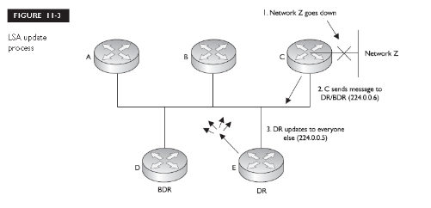

Troubleshooting OSPF
Once you have configured OSPF, you have a variety of commands available to view and troubleshoot your configuration and operation of OSPF:
■ show ip protocols
■ show ip route
■ show ip ospf interface
■ show ip ospf neighbor
■ debug ip ospf adj
■ debug ip ospf events
■ debug ip ospf packet

EIGRP
The Enhanced Interior Gateway Routing Protocol (EIGRP) is a Cisco-proprietary routing protocol for IP. It’s actually based on IGRP, with many enhancements built into it. Because it has its roots in IGRP, the configuration is similar; however, it has many link state characteristics that were added to it to allow EIGRP to scale to enterprise network sizes. These characteristics include:
■ Fast convergence
■ Loop-free topology
■ VLSM and route summarization
■ Multicast and incremental updates
■ Routes for multiple routed protocols
Characteristics of EIGRP
Here is a brief comparison of EIGRP and IGRP:
■ Both offer load balancing across six paths (equal or unequal).
■ They have similar metric structures.
■ EIGRP has faster convergence (triggered updates and saving a neighbor’s routing table locally).
■ EIGRP has fewer networks overhead, since it uses incremental updates.
EIGRP and IGRP use the same metric structure. Both can use bandwidth, delay, reliability, and MTU when computing a best metric path to a destination. By default, only bandwidth and delay are used in the metric computation. One interesting point about these protocols is that if you have some routers in your network running IGRP and others running EIGRP and both sets have the same autonomous system number, routing information will automatically be shared between the two. The routers have to perform a conversion concerning the metrics. Even though both protocols use the same metric components, they store them indifferent size values: EIGRP uses a 32-bit metric, while IGRP uses a 24-bit metric. When integrating the two protocols together, EIGRP routes are divided by 256 to fit a 24-bit metric structure when passed to IGRP and IGRP routes are multiplied by 256 to fit a 32-bit metric structure when passed to EIGRP.
Interaction with Other EIGRP Routers
EIGRP uses hello packets to discover and maintain neighbor relationships. EIGRP generates hello packets every 5 seconds on LAN, point-to-point, and multipoint connections with speeds of at least T1/E1 speeds. Otherwise, hellos are generated every 60 seconds. The dead interval period is three times the hello interval. EIGRP uses the multicast address of 224.0.0.10 for the destination in the hello packets.
For EIGRP routers to become neighbors, the following information must match:
■ The AS number
■ The K-values (these enable/disable the different metric components)
Unlike OSPF, the hello and hold-down timers on two routers do not need to match in order for the routers to become neighbors. When two routers determine whether they will become neighbors, they go through the following process:
1. The first router generates a Hello with configuration information.
2. If the configuration information matches, the second router responds with an Update message with topology information.
3. The first router responds with an ACK message, acknowledging the receipt of the second’s ACK.
4. The first router sends its topology to the second router via an Update message.
5. The second router responds back with an ACK.
Configuring EIGRP
Setting up EIGRP is almost as simple as configuring IGRP:
Router(config)# router eigrp autonomous_system_#
Router(config-router)# network IP_network_#
As you can see from these commands, EIGRP is configured the same as IGRP. Need to enter an autonomous system number and network statements for interfaces that will participate in EIGRP.
Configuration Example
Let’s look at an example, shown previously in Figure 11-4, to help illustrate how to configure EIGRP on a router. Here’s the routing configuration of the router:
Router(config)# router eigrp 200
Router(config-router)# network 172.16.0.0
Router(config-router)# network 10.0.0.0
This router has four interfaces: 172.16.1.1/24, 172.16.2.1/24, 10.1.1.1/24, and10.1.2.1/24. Remember, when configuring your network commands, to put in only the Class A, B, or C network numbers. In the preceding example, the class B and A network numbers were entered, activating EIGRP routing on all four interfaces.
Troubleshooting EIGRP
Here are some of the main commands you’ll use when viewing and troubleshooting EIGRP
■ show ip protocols
■ show ip route
■ show ip eigrp neighbors
■ show ip eigrp topology
■ show ip eigrp traffic
■ debug ip eigrp

VLSM
VLSM, allows you to apply different subnet masks to the same class address. For instance, a good or point-to-point links is 255.255.255.252, which provides for two host addresses in each network. A good mask for a LAN connection might be 255.255.255.192, which provides for 62 host addresses for each network. Using a 255.255.255.252 mask for a LAN connection will not give you enough host address, and using a 255.255.255.192 mask on a point-to-point connection wastes addresses. One solution would be to divide the mask values in the middle to limit the waste of addresses, but this doesn’t scale well. VLSM solves this problem by enabling you to use different subnet mask values on the same class address space.
Features of VLSM
VLSM provides two major advantages:
■ More efficient use of addressing
■ Ability to perform route summarization
As these bullets suggest, one advantage of VLSM is that it allows you to make more efficient use of your IP addressing. Figure 12-1 shows a simple before-and-after example of using VLSM. In this example, there is a router at the corporate site (RouterA) with point-to-point WAN connections to the remote office routers (RouterB, RouterC, and RouterD). The LAN segments at these remote sites have about 50 devices (thus the /26) mask. In the before design, a single subnet mask is chosen: 255.255.255.192, which allows 62 hosts per subnet. Because of the number of segments, two Class C networks were needed. On theWAN segments, this wastes a lot of addressing space. The bottom part of Figure 12-1 shows a more efficient use of addressing, using VLSM. In this example, the three remote sites have a 255.255.255.192 mask, but the last subnet, 192.168.1.192/26 was assigned a different subnet mask. And these little subnetted subnets were then assigned to the point-to-point links of the WAN connections. Given the VLSM solution, only one Class C network was needed to assign addressing to this network. The second advantage of VLSM, route summarization,

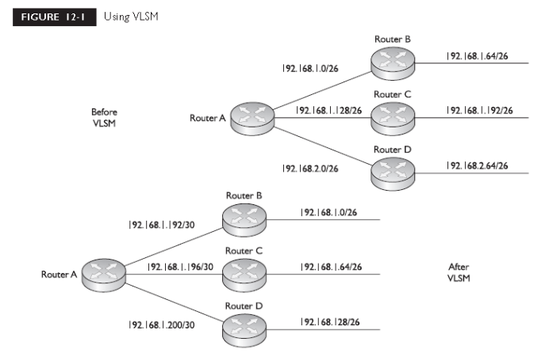
VLSM Example 1
In this example, you are given a Class C network: 192.168.2.0/24. You are tasked to use VLSM to accommodate the following requirements: each remote site (total of 7) has no more than 30 devices. The links between the central and remote routers are point-to-point. For this example, you first need to worry about handling the largest segments, which are the remote sites with 30 devices. To handle 30 devices, you need a 225.255.255.224 (/27) subnet mask. This mask results in the following subnets: 192.168.2.0/27, 192.168.2.32/27, 192.168.2.64/27, 192.168.2.96/27, 192.168.2.128/27, 192.168.2.160/27,
192.168.2.192/27and 192.168.2.224/27. With a /27 mask, you have actually created eight subnets; however, you need only seven for the remote offices. This leaves you one subnet mask, but seven point-to-point links between the central and remote routers. Let’s assign the first seven subnets for the remote LAN segments and use the last subnet (192.168.2.224/27) for the point-to- point links. To accommodate the point-to-point links, use a 255.255.255.252 (/30) subnet mask. This result in the following subnetted subnets: 192.168.2.224/30, 192.168.2.228/30, 192.168.2.232/30, 192.168.2.236/30, 192.168.2.240/30, 192.168.2.244/30, 192.168.2.248/30, and 192.168.2.252/30. With a /30 mask on the 192.168.2.224 subnet, you have created eight little subnets. You need only seven for the point-to-point links, which leaves one small subnet left over. Figure 12-3 shows the actual networking layout based on this example. Notice that this example used two subnet mask values: 255.255.255.224 and 255.255.255.252.
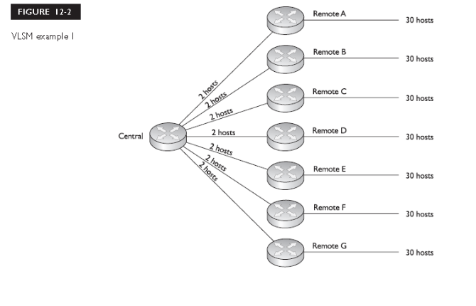
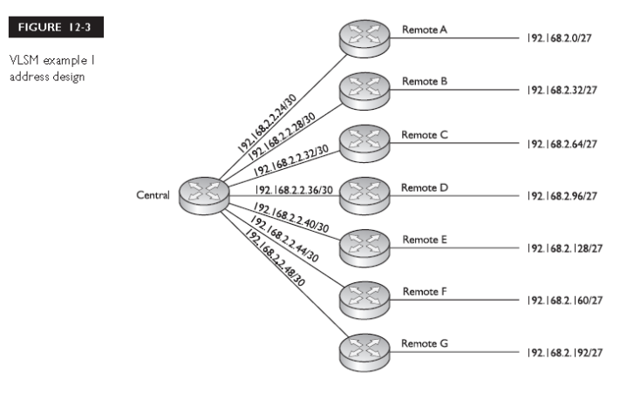

Route Summarization
Route summarization is the ability to take a bunch of contiguous network numbers in your routing table and advertise these contiguous routes as a single summarized route. VLSM allows you to summarize subnetted routes back to the class boundary. For instance, if you have 192.168.1.0/24 and have subnetted it to 192.168.1.0/26, giving you four networks, you could summarize these subnets in your routing table and advertise them as the Class C network number 192.168.1.0/24, as is shown in Figure 12-6. In this example, you have reduced your routing entries from 4 down to 1 in your routing updates.

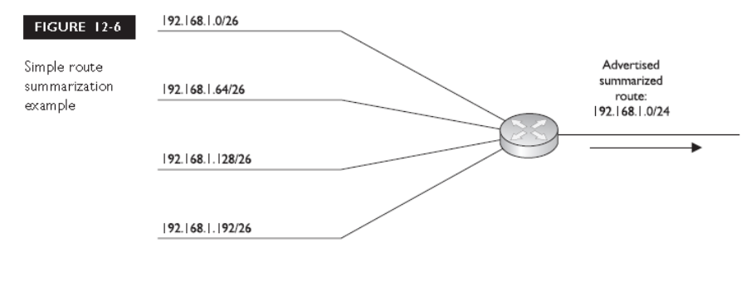

Advantages of Summarization
Summarization allows you to create a more efficient routing environment by providing
the following advantages:
■ It reduces the size of routing tables, requiring less memory and processing.
■ It reduces the size of updates, requiring less bandwidth.
■ It contains network problems.
Classless Interdomain Routing
Classless Interdomain Routing (CIDR), specified in RFC 2050, is an extension to VLSM and route summarization. With VLSM, you can summarize subnets back to the Class A, B, or C network boundary. For example, if you have a Class C network 192.168.1.0/24 and subnet it with a 26-bit mask, you have created four subnets. Using VLSM and summarization, you can summarize these four subnets back to 192.168.1.0/24. CIDR takes this one step further and allows you to summarize a block of contiguous class A, B, and C network numbers. This practice is commonly referred to as supernetting. Figure 12-7 shows an example of CIDR. In this example, a router is connected to four networks: 192.168.0.0/24, 192.168.1.0/24, 192.168.2.0/24, and 192.168.3.0/24. The router is summarizing these routes into a single entry: 192.168.0.0/22.

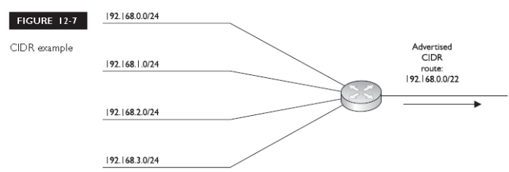
Routing and Subnet Masks
As mentioned in the preceding section, the routing protocol must carry the subnet mask with the corresponding network entries if you want to take advantage of route summarization. Otherwise, if you had more than one subnet mask applied to a class network number, the router wouldn’t know which mask to use when routing a packet to a destination. A good example of this problem is apparent in classful protocols, such as RIPv1 and IGRP, and how you lay out your IP addresses in your network.With classful protocols, routing updates are sent out with only network entries: no subnet masks are included. The assumption is that the routers on other segments are connected to the same class network and thus know about the subnet mask. If a network number crosses boundaries from one class network to another, the classful protocol will automatically summarize it to the class address network number (A, B, or C), as is shown in the top part of Figure 12-9. As you can see, the classful protocol advertises just the network number (172.16.0.0) without any subnet mask. Plus, since the network number crosses a class boundary (172.16.0.0 to 192.168.1.0), the subnet (172.16.1.0) is not advertised, but instead the class address (172.16.0.0) is. Given the routing behavior of classful routing protocols, certain addressing designs will create problems. Let’s use the network shown in the top part of Figure 12-10. With a classful protocol, like RIPv1, the routers, when advertising networks across a class boundary, summarize them back to their class boundary. In this example, both RouterA and RouterB advertise 172.16.0.0—they don’t advertise their specific subnets for 172.16.0.0. This creates a problem with RouterC, which receives two routes for 172.16.0.0. If RouterC wanted to reach 172.16.1.0/24, it really wouldn’t know which router (RouterA or RouterB) to send its packets to. This network design is referred to as a discontiguous subnet design—not all of the subnets are connected together. In this network, 172.16.1.0/24 and 172.16.2.0/24 are not connected via another 172.16.0.0 subnet number. This creates routing problems for other routers not connected to the 172.16.0.0 network, and therefore, discontiguous subnet designs are not recommended with classful protocols.

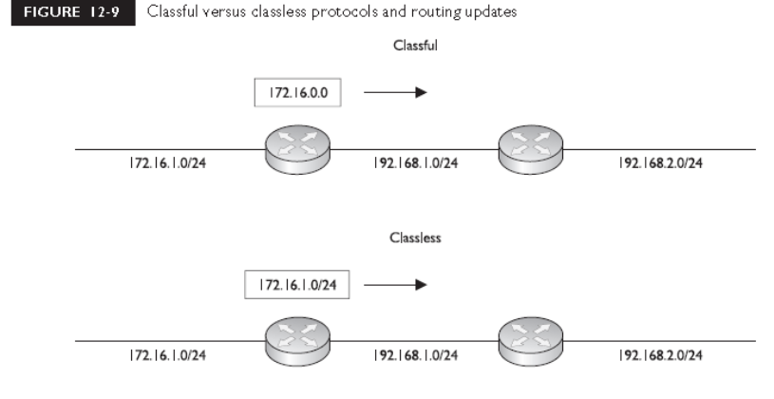

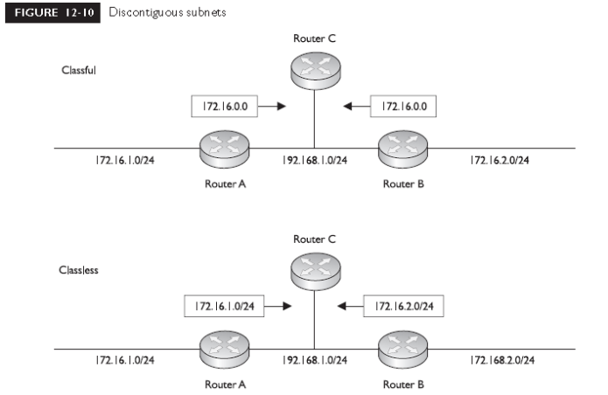
The Routing Table
When implementing route summarization, another thing you’ll need to consider is that routing decisions, by a router, must be made on the entire destination IP address in the IP packet header. The router always uses the longest matching prefix in the routing table to perform its routing decision. Let’s use the following simplified routing table to illustrate the router’s decision-making process:
1. 172.16.17.66/32
2. 172.16.17.64/27
3. 172.16.17.0/24
4. 172.16.0.0/16
5. 0.0.0.0/0
A router receives an inbound packet on one of its interfaces and examines the destination IP address in the packet header: 172.16.17.65. The router then needs to examine its routing table and find the best match for this packet and then route the packet out the corresponding interface to reach the destination. The router will basically sort the entries in the routing table from the most bits in a mask to the least
number of bits.
ACL Overview
ACLs(acess control lists) known for their ability to filter traffic as it either comes into or leaves an
interface, can also by used for other purposes, including the following:
■ Restricting telnet (VTY) access to a router
■ Filtering routing information
■ Prioritizing WAN traffic with queuing
■ Triggering phone calls with dial-on-demand routing (DDR
■ Changing the administrative distance of routes
Definition
ACLs are basically a set of commands, grouped together by a number or names that are used to filter traffic entering or leaving an interface. ACL commands define specifically which traffic is permitted and which is denied. ACLs are created in Global Configuration mode. Once you create your group of ACL statements, you must activate them. For filtering traffic between interfaces, the ACL is activated in Interface Subconfiguration mode. This can be a physical interface, like ethernet0 or serial0, or a logical interface, like ethernet0.1 or serial0.1. When activating an ACL on an interface, you must specify in which direction the traffic should be filtered:
■ Inbound (as the traffic comes into an interface)
■ Outbound (before the traffic exits an interface)
With inbound ACLs, the router compares the packet to the interface ACL before the router will forward it to another interface. With outbound ACLs, the packet is received on an interface and forwarded to the exit interface; the router then compares the packet to the ACL. One restriction that ACLs have is that they cannot filter traffic that the router originates itself. For example, if you execute a ping or traceroute from the router, or if you telnet from the router to another device, ACLs applied to the router’s interfaces cannot filter these connections

Types
ACLs come in two varieties:
■ Numbered and named
■ Standard and extended
Numbered and named ACLs define how the router will reference the ACL. You can view this as something similar to an index value. A numbered ACL is assigned a unique number among all ACLs, whereas a named ACL is assigned a unique name among all named ACLs. These are then used by the router to filter traffic. Each of these references to ACLs supports two types of filtering: standard and extended. Standard IP ACLs can filter only on the source IP address inside a packet, whereas an extended IP ACLs can filter on the source and destination IP addresses in the packet, the IP protocol (TCP, UDP, ICMP, and so on), and protocol information (such as the TCP or UDP source and destination port numbers).With an extended ACL, you can be very precise in your filtering. For example, you can filter a specific telnet session from one of your user’s PCs to a remote telnet server. Standard ACLs do not support this form of granularity. With a standard ACL, you can either permit or deny all traffic from a specific source device. Table 13-1 compares the two types of filtering for IP traffic.

Processing
ACLs are basically statements that are grouped together by either a name or a number. Within this group of statements, when a packet is processed by an ACL on the router, the router will go through certain steps in finding a match against the ACL statements. ACLs are processed top-down by the router. Using a top-down approach, a packet is compared to the first statement in the ACL, and if the router finds a match between the packet and the statement, the router will execute one of two actions included with the statement:
■ Permit
■ Deny
If the router doesn’t find a match of packet contents to the first ACL statement, the router will proceed to the next statement in the list, again going through the same matching process. If the second statement matches, the router executes one of the two actions. If there isn’t a match on this statement, the router will keep on going through the list until it finds a match. If the router goes through the entire list and doesn’t find a match, the router will drop the packet. The top-down processing of ACLs brings out the following very important points:
■ Once a match is found, no further statements are processed in the list.
■ The order of statements is important.
■ If no match is found in the list, the packet is dropped.
Let’s take a look at an example to illustrate this process. In this example, you have an ACL on your router with two statements in this order:
1. Permit traffic from subnet 172.16.0.0/16.
2. Deny traffic from host 172.16.1.1.
Remember that the router processes these statements top-down. Let’s assume that a packet is received on the router with a source IP address of 172.16.1.1. Given the preceding ACL, the router compares the packet contents with the first statement. Does the packet have a source address from network 172.16.0.0/16? Yes. Therefore, the result indicates that the router should permit the packet. Notice that the second statement is never processed once the router finds a match on a statement. In this example, any traffic from the 172.16.0.0/16 subnet is permitted, even traffic from 172.16.1.1.
Implicit Deny
Another important aspect of the top-down process is that if the router compares a packet to every statement in the list and does not find a match against the packet contents, the router will drop the packet. This process is referred to as implicit deny

Basic ACL Configuration
To create an ACL, use the following command:
Router (config) # access-list ACL_# permit|deny conditions
The purpose of the ACL_# is to group your statements together into a single list. You cannot choose just any number for an ACL. Each layer-3 protocol is assigned its own range or ranges of numbers. Numbered ACLs, have a limited number of lists that you can create, which is based on the range of numbers assigned to a protocol type. The condition in an ACL statement tells the router what contents in the packet need to match in order for the router to execute the action (permit or deny). The condition can include matching of IP addresses and protocol information. When the router compares a packet to the condition, if it finds a match, no more ACL statements are processed; otherwise, the router proceeds to compare the packet to the next ACL statement in the list.
Activating an ACL
to have your router filter traffic between interfaces, you must enter the appropriate interface or
interfaces and activate your ACL. Here’s the command to activate it on an interface:
Router(config)# interface type [module_#]port_#
Router(config-if)# ip access-group ACL_# in|out

IP Standard 1–99, 1300–1999
Standard Vines 1–99
IP Extended 100–199, 2000–2699
Extended Vines 100–199
Bridging type code (layer-2) 200–299
DECnet 300–399
Standard XNS 400–499
Extended XNS 500–599
AppleTalk 600–699
Bridging MAC address and vendor code 700–799
IPX Standard 800–899
IPX Extended 900–999
IPX SAP filters 1000–1099
Extended transparent bridging 1100–1199
IPX NLSP 1200–1299
TABLE 13-2
At the end of the ip access-group command, you must specify which ACL
you are activating and in which direction:
■ in As traffic comes into the interface
■ out As traffic leaves the interface
In IOS 12.0 and later, you have to specify one of the two directions. In 11.3 and, you did not have to enter the direction. If you omitted the direction, it defaulted to out. For an ACL to have an implicit deny, it needs at least one permit or deny statement. It is highly recommended that you do not apply nonexistent ACLs to a router’s interface. In this situation, when you create the very first statement in the list, the implicit deny is automatically placed at the bottom, which might create reachability issues for you.

Wildcard Masks
When dealing with IP addresses in ACL statements, you can use wildcard masks to atch on a range of addresses instead of having to manually enter every IP address you want to match on. With a wildcard mask, a 0 in a bit position means that the corresponding bit position in the address of the ACL statement must match the bit position in the IP address in the examined packet. A 1 in a bit position means that the corresponding bit position in the address of the ACL statement does not have to match the bit position in the IP address in the examined packet. In reality, a wildcard mask is more like an inverted subnet mask. For instance, if you want to match on any address in a subnet or network, all you need to do is to take the subnet mask, invert its bit values (change the 1's to 0's and the 0's to 1's), and you have a corresponding wildcard mask.. Let’s assume that you have subnet mask of 255.255.0.0. Its binary representation is 11111111.11111111.0000000.00000000.When you convert this to a wildcard mask, invert the bits, like this: 00000000.00000000.11111111.11111111.
Types of ACLs
Standard Numbered ACLs
Standard IP ACLs are simple and easy to configure. First, standard IP ACLs filter on only the source IP address in an IP packet. Use the following command to create an entry in a standard numbered IP ACL:
Router (config) # access-list 1-99|1600-1999 permit|deny
source_IP_address
[wildcard_mask][log]
With a standard numbered IP ACL, you can use list numbers of 1–99 and 1600–1999.The condition is based solely on the source IP address. You enter this followed by an optional wildcard mask. If you omit the mask, it defaults to 0.0.0.0—an exact match is required in order to execute the action. Following this is the optional log parameter, which is new to standard ACLs in IOS 12.0. This parameter will cause any match of this statement to be printed to the console port of the router. These messages, by default, will not appear on telnet connection to the router unless you execute the following:
Router# terminal monitor
Activating a Standard IP ACL
Once you have created your ACL, you can proceed to activate it on a router’s interface with the following configuration:
Router(config)# interface type [module_#]port_#
Router(config-if)# ip access-group ACL_# in|out

Standard IP ACL Examples
Now that you have been introduced to the two basic commands to create and activate a standard numbered IP ACL Here’s the first example:
Router(config)# access-list 1 permit 192.168.1.1
Router(config)# access-list 1 deny 192.168.1.2
Router(config)# access-list 1 permit 192.168.1.0 0.0.0.255
Router(config)# access-list 1 deny any
Router(config)# interface serial 0
Router(config-if)# ip access-group 1 in
the first ACL statement in ACL #1 says that in order to execute the permit action, the IP packet must have a source address of 192.168.1.1—if it doesn’t, the router proceeds to the second statement. Remember that if you omit the wildcard mask on a standard ACL, it defaults to 0.0.0.0—an exact match of the corresponding address in the ACL statement. The second ACL statement says that in order to execute the deny action, the IP packet must have a source address of 192.168.1.2; if it doesn’t, the router proceeds to the third statement. The third ACL statement says that in order to execute the permit action, the IP packet must have a source address between 192.168.1.0 and 192.168.1.255—if it doesn’t, the router proceeds
Restricting Telnet Access to the Router
Besides using standard IP ACL’s to filter traffic as it enters and/or leaves an interface, you can also use them to restrict telnet access to your router. First, you need to create a standard ACL that has a list of permit statements that allow your corresponding network administrators telnet access; include the IP addresses of their PCs in this list. Next, you need to activate your ACL. However, you will not do this on any of the router’s interfaces. If you were to activate this ACL on an interface, it would allow any type of traffic from your administrators but drop all other traffic. When someone telnets into your router, the router associates this connection with a virtual terminal (VTY) line. Therefore, you’ll apply your standard ACL to the VTYs, like this:
Router (config)# line vty 0 4
Router (config-line) # access-class standard_ACL_# in|out
Remember that your router supports five telnets by default (0–4). You can configure all VTY simultaneously by specifying the beginning and ending line numbers after the vty parameter. If you don’t apply the restriction to all of your VTYs, then you’re leaving a backdoor into your router, which might cause a security problem. Here’s a simple example of using a standard ACL to filter telnet traffic to a router:
Router (config) # access-list 99 permit 192.168.1.0 0.0.0.255
Router (config) # line vty 0 4
Router (config-line) # access-class 99 in
In this example, only traffic from 192.168.1.0/24 is allowed to telnet in this router. Because of the implicit deny at the end of access-list 99, all other telnets to this router will be dropped.

Address Translation Overview
Running Out of Addresses
To solve the addressing problem a new addressing format was developed called IPv6. Whereas the current IP addressing scheme (IPv4) uses 32 bits to represent addresses, IPv6 uses 128 bits for addressing, creating billions of extra addresses.
Address Translation
A second standard, RFC 1631, was created and was defined as Network Address Translation (NAT), which allows you to change an IP address in a packet to a different address. When communicating to devices in a public network, your device needs to use a source address that is a public address. Address translation allows you to translate your internal private addresses to public addresses before these packets leave your network.

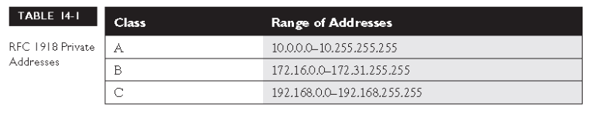

Here are some common reasons that you might need to employ address translation:
■ You have to use private addressing because your ISP didn’t assign you enough public addresses.
■ You are using public addresses but have changed ISPs, and your new ISPwon’t support these public addresses.
■ You are merging two companies together and they are using the same address space, for instance, 10.0.0.0, which creates routing and reachability issues.
■ You want to assign the same IP address to multiple machines so that users on the Internet see this offered service as a single logical computer.
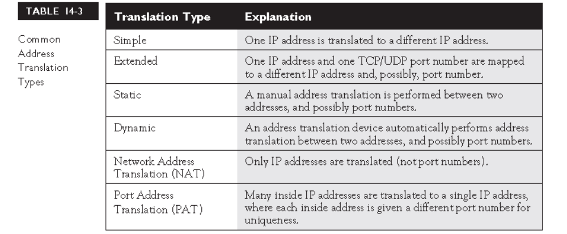

Types of Address Translation
Address translation comes in a variety of types, like Network Address Translation (NAT), Port Address Translation (PAT), dynamic address translation, and static address translation.
Network Address Translation
Network Address Translation (NAT) translates one IP address to another. This can source address or a destination address. There are two basic implementations of NAT: static and dynamic. The following two sections cover the mechanics of these implementations.
Static NAT With static NAT, a manual translation is performed by an address translation device, translating one IP address to a different one. Typically, static NAT is used to translate destination IP addresses in packets as they come into your network, but you can translate source addresses also. Figure 14-1 shows a simple example of outside users trying to access an inside web server. In this example, you want Internet users to access an internal web server, but this server is using a private address (10.1.1.1). This creates a problem, since if an outside user would put a private address in the destination IP address field, their ISP would drop this. Therefore, the web server needs to be presented as a having a public address. This is defined in the address translation device (in our case, this is a Cisco router).The web server is assigned an inside global IP address of 200.200.200.1 on the router, and your DNS server advertises this address to the outside users. When outside users send packets to the 200.200.200.1 address, the router examines its translation table for a matching entry. In this case, it sees that 200.200.200.1maps to 10.1.1.1. The router then changes the destination IP address to 10.1.1.1 and forwards it to the inside web server. Likewise, when the web server sends traffic out to the public network, the router compares the source IPaddress to entries in its translation table, and if it finds a match, it changes the inside local IP address (private source address--10.1.1.1) to the inside global IP address(public source address--200.200.200.1).
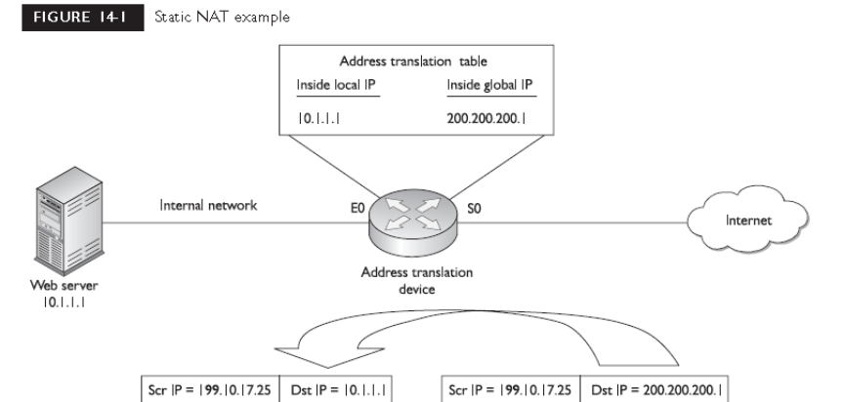
Dynamic NAT With static address translation, you need to manually build the translations. Typically, static translation is done for inside resources that outside people want to access. When inside users access outside resources, dynamic NAT is typically used. In this situation, the address assigned to the internal user isn’t that important, since outside devices don’t directly access your internal users—they just return traffic to them that the inside user requested. With dynamic NAT, you must manually define two sets of addresses on your address translation device. One set defines which inside addresses are allowed to be translated, and the other defines what these addresses are to be translated to. When an inside user sends traffic through the address translation device, say a router, it examines the source IP address and compares it to the internal local address pool. If it finds a match, then it determines which inside global address pool it should use for the translation. It then dynamically picks an address in the global address pool that is not currently assigned to an inside device. The router adds this entry in its address translation table, and the packet is then sent to the outside world. If no entry is found in the local address pool, then the address is not translated and forwarded to the outside world in its original state.
Port Address Translation
One problem with static or dynamic NAT is that it provides only a one-to-one address translation. Therefore, if you have 5,000 internal devices with private addresses, and all 5,000 devices try to reach the Internet simultaneously, you need 5,000 public addresses in your inside global address pool. If you have only 1,000 public addresses, only the first 1,000 devices are translated and the remaining 4,000 won’t be able to reach outside destinations. To overcome this problem, you can use a process called address overloading. There are actually many terms used to describe this process, including Port Address Translation (PAT) and Network Address Port Translation (NAPT).
Using the Same IP Address With PAT, all machines that go through the address translation device have the same IP address assigned to them, and so the source port numbers are used to differentiate the different connections. If two devices have the same source port number, the translation device changes one of them to ensure uniqueness. When you look at the translation table in the address
Translation device, you’ll see the following items:
■ Inside local IP address (original source private IP)
■ Inside local port number (original source port number)
■ Inside global IP address (translated public source IP)
■ Inside global port number (new source port number)
■ Outside global IP address (destination public address)
■ Outside global port number (destination port number)

Advantages of Address Translation
As mentioned at the beginning of this part of the chapter, address translation devices are typically used to give you an almost inexhaustible number of addresses as well as to hide your internal network addressing scheme. Another advantage of address translation is that if you change ISPs or merge with another company, you can keep your current scheme and make any necessary changes on your address translation device or devices, making your address management easier. Another big advantage that address translation provides is that it gives you tighter control over traffic entering and leaving your network
Disadvantages of Address Translation
Even though address translation solves many problems and has many advantages, it also has its share of disadvantages. Here are the three main issues with address translation:
■ Each connection has an added delay.
■ Troubleshooting is more difficult.
■ Not all applications work with address translation.
Since address translation changes the contents of packets and, possibly, segment headers, as well as computing any necessary new checksum values, extra processing is required on each packet. This extra processing, obviously, will affect the throughput and speed of your connections.
Static NAT
As mentioned earlier in this chapter, static NAT is typically used when devices on the outside of your network want to access resources, such as web, DNS, and email servers, on the inside. Here are the two commands to define the static translations for NAT:
Router (config) # ip nat inside source static
inside_local_source_IP_address
inside_global_source_IP_address
Router (config) # ip nat outside source static
outside_global_destination_IP_address
outside_local_destination_IP_address
The inside and outside parameters specify the direction in which translation will occur. For instance, the inside keyword specifies that the inside source local IP addresses are translated to an inside global IP address. The outside keyword changes the outside destination global IP address to an outside localaddress.After you configure your translations; you must specify which interfaces on your router are considered to be on the inside and which ones are on the outside. This is done with the following configuration:
Router (config) # interface type [slot_#/] port_#
Router (config-if) # ip nat inside|outside
Specify inside for interfaces connected to the inside of your network and outside for interfaces connected to external networks. Figure 14-3 for this example. In this example, an internal web server (10.1.1.1) will be assigned a global IP address of 200.200.200.1.Here’s the configuration:
Router (config) # ip nat inside source static
192.168.1.1 200.200.200.1
Router (config) # interface ethernet 0
Router (config-if) # ip nat inside
Router (config-if) # exit
Router (config) # interface serial 0
Router (config-if) # ip nat outside
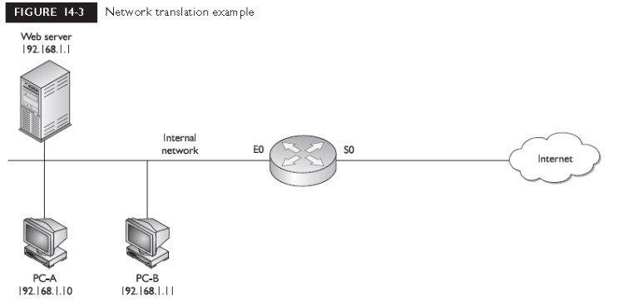

Dynamic NAT
When you are configuring dynamic NAT, you’ll need to configure three things: what inside addresses are to be translated, what global addresses will be used for the dynamic translation, and what interfaces are involved in the translation. To specify what internal devices will have their source address translated, use the following command:
Router (config) # ip nat inside source
list standard_IP_ACL_#
pool NAT_pool_name
The ip nat inside source list command requires you to configure a standard IP ACL that has a list of the inside source addresses that will be translated—any addresses listed with a permit statement will be translated, and any addresses listed with a deny, or the implicit deny, statement will not be translated. Following this is the name of the address pool. This ties together the address pool you’ll use that contains your global source IP addresses. To create the pool of source inside global IP addresses, use this command:
Router(config)# ip nat pool NAT_pool_name
beginning_inside_global_IP_address
ending_inside_global_IP_address
netmask subnet_mask_of_addresses
The pool name that you specify references the inside addresses that will be translated from the ip nat inside source list command. Next, list the beginning and ending IP addresses in the pool, followed by the subnet mask for the addresses Figure 14-3 to illustrate how dynamic NAT is configured. In this example, the two PCs will have dynamic NAT performed on them.
Router(config)# ip nat inside source list 1 pool nat-pool
Router(config)# access-list 1 permit 192.168.1.10 0.0.0.0
Router(config)# access-list 1 permit 192.168.1.11 0.0.0.0
Router(config)# ip nat pool nat-pool 200.200.200.2
200.200.200.3 netmask 255.255.255.0
Router(config)# interface ethernet 0
Router(config-if)# ip nat inside
Router(config-if)# exit
Router(config)# interface serial 0
Router(config-if)# ip nat outside

PAT Configuration
The last example showed an example of dynamic NAT. This section covers how to configure PAT on your router. This configuration requires three basic translation commands. The first thing you specify
is which inside devices will have their source addresses translated.
Router(config)# ip nat inside source
list standard_IP_ACL_#
pool NAT_pool_name overload
Next, you specify the global pool to use. Again, you’ll use the same command as you used in dynamic NAT:
Router(config)# ip nat pool NAT_pool_name
beginning_inside_global_IP_address
ending_inside_global_IP_address
netmask subnet_mask_of_addresses
You can specify more than one address to use in PAT, or you can specify a single address (use the same address for the beginning and ending addresses). And last you have to tell the IOS which interfaces are inside and outside, respectively, in terms of the ip nat inside and ip nat outside commands. Let’s use Figure 14-3 to illustrate how PAT is configured. In this example, only a single IP address is placed in the address pool (200.200.200.2):
Router(config)# ip nat inside source list 1 pool
nat-pool overload
Router(config)# access-list 1 permit 192.168.1.10 0.0.0.0
Router(config)# access-list 1 permit 192.168.1.11 0.0.0.0
Router(config)# ip nat pool nat-pool 200.200.200.2
200.200.200.2
netmask 255.255.255.0
Router(config)# interface ethernet 0
Router(config-if)# ip nat inside
Router(config-if)# exit
Router(config)# interface serial 0
Router(config-if)# ip nat outside

Wide Area Networking Overview
Typically, LAN connections are within a company and WAN connections allow you to connect to remote sites. A derivative of WAN solutions is the metropolitan area network (MAN). MANs sometimes use high-speed LAN connections in a small geographic area between different companies, or divisions within a company.

Connection Types
Leased-Line Connections
A leased-line connection is basically a dedicated circuit connection between two sites. It simulates a single cable connection between the local and remote sites. Leased lines are best suited when both of these conditions hold:
■ The distance between the two sites is small, making them cost-effective.
■ You have a constant amount of traffic between two sites and need to guarantee bandwidth for certain applications.
Even though leased lines can provide guaranteed bandwidth and minimal delay for connections, other available solutions, such as ATM, can provide the same features. The main disadvantage of leased lines is their cost—they are the most expensive WAN solution. Leased lines use synchronous serial connections, with their data rates ranging from2,400 bps all the way up to 45 Mbps, in what is referred to as a DS3 connection. Asynchronous serial connection allows you to simultaneously send and receive information without having to wait for any signal from the remote side. Nor does a synchronous connection need to indicate when it is beginning to send something or the end of a transmission. These two things, plus how clocking is done, aretheIf you purchase a leased line, you will need the following equipment:
■ DTE A router with a synchronous serial interface: this provides the data link framing and terminates the WAN connection.
■ DCE A CSU/DSU to terminate the carrier’s leased-line connection: this provides the clocking and synchronization for the connection.

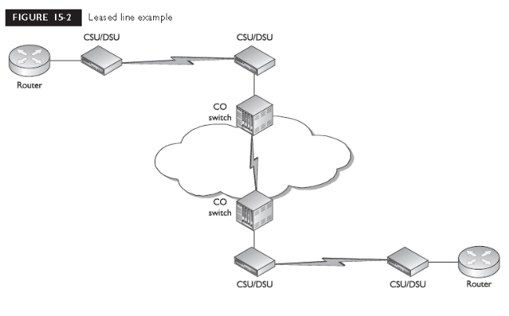
Circuit-Switched Connections
Circuit-switched connections are dialup connections, as are used by a PC with a modem when dialing up an ISP. Circuit-switched connections include the following types:
■ Asynchronous serial connections these include analog modem dialup connections and the standard telephone system, which is commonly referred to as Plain Old Telephone Service (POTS) by the telephone carriers.
■ Synchronous serial connections these include digital ISDN BRI and PRIdialup connections; they provide guaranteed bandwidth. Asynchronous serial connections are the cheapest form of WAN services but are also the most unreliable of the services. For instance, every time you make a connection using an analog modem, there is no guarantee of the connection rate you’ll get

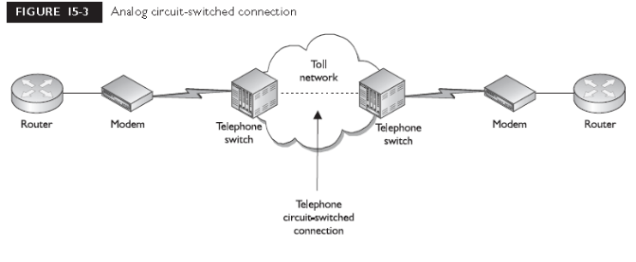
WAN Interfaces on Cisco Routers
Cisco supports a wide variety of serial cables for their serial router interfaces. Here are some of the cable types supported for synchronous serial interfaces: EIA/TIA-232, EIA/TIA-449, EIA/TIA-530, V.35, and X.21.The end that connects to the DCE device is defined by these standards. However, the end that connects to the Cisco router is proprietary in nature. Cisco’s cables have two different end connectors that connect to the serial interfaces
of their routers:
■ DB-60 Has 60 pins
■ DB-26 Has 26 pins and is flat, like a USB cable
Note that these connectors are for synchronous serial connections. Cisco has other cable types, typically RJ-45, for asynchronous connections.
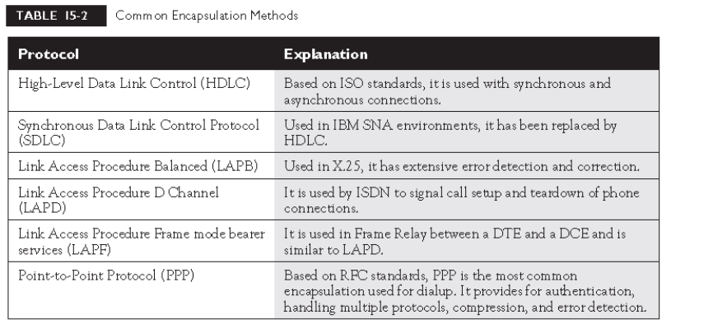
Encapsulation Methods
There are many different methods for encapsulating data for serial connections.Table 15-2 shows the most common ones.
HDLC
Based on ISO standards, the HDLC (High-Level Data Link Control) protocol can be used with synchronous and asynchronous connections and defines the frame type and interaction between two devices at the data link layer.

Configuring HDLC
As mentioned in the preceding section, the default encapsulation on Cisco’s synchronous serial interfaces is HDLC. The configuration is:
Router(config)# interface serial [module_#/]port_#
Router(config-if)# encapsulation hdlc
Notice that you must be in the serial interface to change its data link layer
After you have configured HDLC, use the show interfaces command to view the data link layer encapsulation:
Router# show interfaces serial 1
Serial1 is up, line protocol is up
Hardware is MCI Serial
Internet address is 192.168.2.2 255.255.255.0
MTU 1500 bytes, BW 1544 Kbit, DLY 20000 usec, rely 255/255, load 1/255
Encapsulation HDLC, loopback not set, keepalive set (10 sec)
Last input 0:00:02, output 0:00:00, output hang never
Last clearing of "show interface" counters never
Output queue 0/40, 0 drops; input queue 0/75, 0 drops
<--output omitted-->
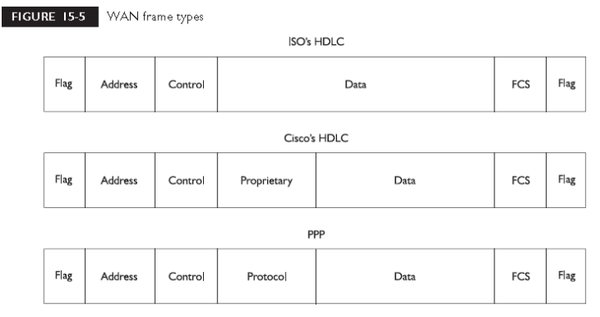

PPP
Where Cisco’s HDLC is a proprietary protocol, PPP works with asynchronous and synchronous serial interfaces as well as High-Speed Serial Interfaces (HSSI) and ISDN interfaces (BRI and PRI).

PPP Components
PPP has many more features than HDLC. Like HDLC, PPP defines a frame type and how two PPP devices communicate with each other, including the multiplexing of network and data link layer protocols across the same link. However, PPP also
■ Performs dynamic configuration of links
■ Allows for authentication
■ Compresses packet headers
■ Tests the quality of links
■ Performs error detection and correction
■ Allows multiple PPP physical connections to be bound together as a single logical connection
PPP has three main components:
■ Frame format
■ LCP (Link Control Protocol)
■ NCP (Network Control Protocol)
LCP and NCP
The second and third components of PPP are LCP and NCP. LCP, defined in RFCs 1548and 1570, has as its primary responsibility to establish, configure, authenticate, and test PPP connection. It handles all of the up-front work in setting up a connection.
■ Authentication method used (PAP or CHAP), if any
■ Compression algorithm used (Stacker or Predictor), if any
■ Callback phone number to use, if defined
■ Multilink: other physical connections to use, if configured
There are three steps that LCP and NCP go through in order to establish a PPPconnection:
1. Link establishment (LCP)
2. Authentication (LCP)
3. Protocol negotiation (NCP)
The first step is the link establishment phase. In this step, LCP negotiates the PPPparameters that are to be used for the connection, which may include the authentication method and compression algorithms. If authentication has been configured, the authentication type is negotiated. This can either be PAP or CHAP If authentication is configured and there’s a match on the authentication type on both sides, then authentication is performed in the second step. If this is successful, NCP, in the third step, will negotiate the upperlayerprotocols, which can include network layer protocols such as IP and IPX as well as data link layer protocols (bridged traffic, like Ethernet, and Cisco’s CDP) that will be transmitted across the PPP link.NCP defines the process for how the two PPP peers negotiate which network layer protocols, such as IP and IPX, will be used across the PPP connection. Once LCP andNCP perform their negotiation and the connection has been authenticated (if this has been defined), the data link layer will come up.
Configuring PPP
The configuration of PPP is as simple as that of HDLC. To specify that PPP is to be used on a WAN interface, use the following configuration:
Router (config) # interface type [slot_#] port_#
Router (config-if) # encapsulation ppp
As you can see, you need to specify the ppp parameter only in the encapsulation Interface Subconfiguration mode command
PPP Authentication
PPP, unlike HDLC, supports device authentication. You have two methods to choose from to implement authentication: the PPP Authentication Protocol (PAP) and the Challenge Handshake Authentication Protocol (CHAP).
PAP
Of the two PPP authentication protocols, PAP is the simplest, but the least secure. During the authentication phase, PAP goes through a two-way handshake process. In this process, the source sends its username (or hostname) and password, in clear text, to the destination. The destination compares this information with a list of locally stored usernames and passwords. If it finds a match, the destination sends back an accept message. If it doesn’t find a match, it sends back a reject message. The top part of Figure 15-6 shows an example of PAP authentication. The configuration of PAP is straightforward. First, you need to determine which side will be the client side (sends the username and password) and which will be the server side (validates the username and password). To configure PAP for a PPP client, use this configuration:
Router(config)# interface type [slot_#]port_#
Router(config-if)# encapsulation ppp
Router(config-if)# ppp pap sent-username your_hostname
password password
To configure the server side of a PPP PAP connection, use the following configuration:
Router(config)# hostname your_router’s_hostname
Router(config)# username remote_hostname
password matching_password
Router(config)# interface type [slot_#/]port_#
Router(config-if)# encapsulation ppp
Router(config-if)# ppp authentication pap
The first thing you must do is to give your router a unique hostname. Second, you must list the remote host names and passwords these remote hosts will use when authenticating to your router. This is accomplished with the username command.
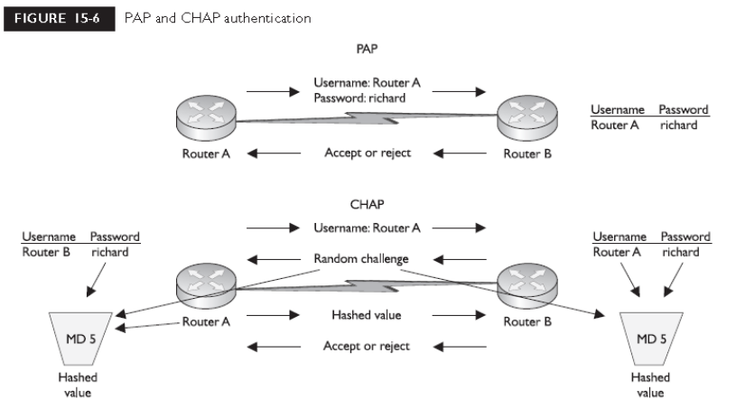
CHAP
One big problem with PAP is that it sends the username and password across the WAN connection in clear text. If someone is tapping into the WAN connection and eavesdropping on the PPP communication, they’ll see the actual password that is being used. In other words, PAP is not a secure method of authentication. CHAP, on the other hand, uses a one-way hash function based on the Message Digest 5 (MD5) hashing algorithm to hash the password. This hashed value is then sent across the wire. In this situation, the actual password is never sent. Anyone tapping the wire will not be able to reverse the hash to come up with the original password.. First, the source sends its username (not its password) to the destination. The destination sends backs challenge, which is a random value generated by the destination. The challenge contains the following information:
■ Packet Identifier Set to 01 for a challenge, 02 for the reply to a challenge, 03for allowing the PPP connection, and 04 for denying the connection
■ ID a local sequence number assigned by the challenger to distinguish among multiple authentication processes
■ Random number the random value used in the MD5 hash function
■ Router name The name of the challenging router (the server), which issued by the source to find the appropriate password to use for authentication Both sides then take the source’s username, the matching password, and the challenge and run them through the MD5 hashing function. The source then takes the result of this function and sends it to the destination. The destination compares this value to the hashed output that it generated—if the two values match, then the password used by the source must have been the same as was used by the destination, and thus the destination will permit the connection. The following configuration shows how to set up two-way CHAP authentication:
Router(config)# hostname your_router’s_hostname
Router(config)# username remote_hostname
password matching_password
Router(config)# interface type [slot_#/]port_#
Router(config-if)# encapsulation ppp
Router(config-if)# ppp authentication chap

REFERENCES

- Sybex CCNA 640-802 cracked

- CCNA 640-802 study guide

